**CHAPTER ONE**

**INTRODUCTION**

**1.1 Background of study**

Over the years, we have beheld structures and machines, as complex as they seem, yet aesthetically bonded together; footwear and electronics, as simple as they look, yet magnificently held together, all thanks to adhesives. An adhesive is any non-metallic substance that can be applied on one surface or both surfaces of two separate objects, which is capable of binding the two surfaces together by surface attachment so as to resist their separation (Ambuja, 2021). It is any non-metallic liquid substance that, by means of adhesive and cohesive forces, changes from liquid state to solid state upon application on the surfaces of a material, to form an adhesive bond between the surfaces (Athavale, 2018). Adhesives generally include; glues, mucilage, pastes, cement as well as the sticky sides of stickers and duct tapes. Cement is considered an inorganic adhesive as it can bind bricks and beams together by surface attachment (Pike, 2022). When compared to other means of joining two or more surfaces together such as stitching, fastening and wielding, adhesives can be used in joining much wider range of materials together as it reduces chances of joint failures by distributing stress efficiently across the joint. It is also a much cheaper alternative to the others.

The use of adhesives spanned from as far back as at when Egyptian carvings showcased the gluing of a piece of veneer on what seemingly appeared to be plank of sycamore, to when the first glue patent was issued in Britain for the type of glue made out of fishes (Bostik, 2015). Today, adhesives have become the indispensable parts of shoes, electronic gadgets, automobiles, cartons, furniture, buildings, non-woven fabrics production processes, as well as the production process of the host of other products. Many manufacturing processes involved in aircraft and aerospace industries are replacing stitching, stapling and fastening with adhesives, greatly influencing the technology of adhesion (Dinte and Sylvester, 2017).

As the growing need of man for stable furniture increased, the use of adhesive in the wood industry had also increased over the years. 70 % of wood products in the world today are made with wood adhesives (Ulker, 2016). Wood adhesives are synthetic glues which are made from petroleum products and other synthetic resins. The synthetic resins used as adhesives are usually dissolved in a solvent before use. As a result, curing of these adhesives after application occurs by solidification through cooling or by evaporation. For the fact that synthetic wood adhesive are gotten from petroleum products, they are categorized based on the nature of the polymer they are made from as; thermoplastic and thermosetting wood adhesives. The thermoplastic wood adhesives are known to be soluble, to soften when they come in contact with heat and solidify upon cooling to room temperature (Frihart and Hunt, 2010). They include polyvinyl acetate (PVAc) and Ethylene-vinyl acetate (EVA) hot melt. Whereas, the thermosetting wood adhesives do not soften upon heating and are insoluble as a result of being cross-linked during curing. Melamine, epoxy, urea-formaldehyde, phenolic, resorcinol and isocyanate resins are all examples of thermosetting synthetic wood adhesives. Urea-formaldehyde is the most popular wood adhesive, which accounts for about 70% usage in the production of particleboards, medium-density fibreboard, interior flush doors and as laminating adhesive for bonding furniture overlays (Kelleci, 2022). This is as a result of its high bonding strength, moderate moisture resistance and quick cure rate.

However, the dependency of synthetic wood adhesives on petroleum resources is a major red flag to the formulation of these adhesives, as there would be an unhealthy competition for the resources. Furthermore, interior doors and furniture made from these adhesives pose health threat to humans and reduces the quality of indoor air by the emission of volatile organic compounds and formaldehyde (Jiang *et al.,* 2019). Formaldehyde is a chemical compound toxic by ingestion, inhalation and skin absorption and it is classified as toxic for humans by the International Agency for Research on Cancer (IARC) (Monteiro, 2020). The various research efforts made to reduce the content of formaldehyde in adhesive formulations could not solve the major issue involved, which is the sustainability of the raw material (petroleum resources), as such, there is a rapid growth of interest in renewable and environmentally-friendly wood bio-adhesives. Hence, this research work; the formulation and characterization of low-cost, formaldehyde – free and high-performance starch-based wood adhesive.

**1.2 Basic principles of adhesives**

Cohesive and adhesion forces are the primary properties of adhesives on which the strength of bonding between an adhesive and the adherents (surfaces to be bonded) greatly depends on (Glavas, 2011). Adhesion results from the molecular contact between an adhesive and a surface and the surface forces that develop which are usually indicated as Van der Waal’s forces (Opara *et al.,*, 2017). For an adhesive to develop these forces, it must make intimate molecular contact with the surface(s) to be bonded. The fundamental requirements of an adhesive is that; it must be able to continuously establish contact between the adherents and itself (termed as wetting) and then, harden to a cohesively strong solid (Athavale, 2011). In much simpler terms, to enable the bond between an adhesive and the adherent, the adhesive must first wet the surface. To be able to wet the surface, the adhesive must spread and make a contact angle approaching zero, Fig. 1. When the contact angle between an adhesive and an adherent becomes zero, complete wetting is said to have occurred or that the adhesive has spread uniformLy over the adherent to form a thin sheet or film. The ability of an adhesive to wet a surface is dependent on a factor called the surface energy (Fraunhofer, 2012). For a favourable wetting to be obtained, the surface energy of the adherent must be high and that of the adhesive, low.

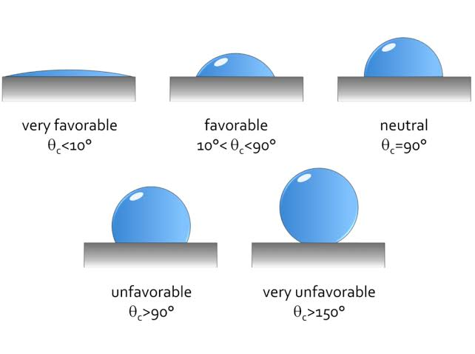





θ = 0°

Low surface energy

Excellent wetting

θ < 90°

Medium surface energy

Good wetting

θ > 90°

High surface energy

No wetting

= Substrate = Adhesive

**Fig. 1**: Wettability of an adhesive (Matthias and Troia, n.d)

In addition, a good adhesive must not only wet the substrate, but also have the right rheological properties to penetrate pores on the surfaces of the adherents, in order to hold them together by interlocking (Manoj, 2022). This is the mechanical theory of adhesion, and it states that for an adhesive to function properly, the adhesive must penetrate the pores on the adherent’s surface, displacing the trapped air at the interface and interlock mechanically to the adherent (Ebnesajjad and Landrock, 2015). The roughness of the adherent’s surfaces plays a vital role in mechanical interlocking theory of adhesion, as it enhances adhesion by increasing the total contact area between the adhesive and the surface, which resultantly increases by a proportional amount the total surface energy interaction (Packham, 2017).

**1.3 Classifications of adhesives**

There are different types and categories of adhesives and they are chosen for a particular application based on the nature of the substrates being bonded, the conditions under which the bond will be exposed and the desired strength and durability of the bond. Ambuja (2021) classified adhesives based on the source of materials they were made from as; natural, synthetic, semi-synthetic and inorganic adhesives. Natural adhesives are otherwise known as bio-adhesives and they include; casein glue, bone glue, and other vegetable starch glue. Based on the composition of chemicals, Sancaktar (2011) classified adhesives as; epoxy, polyurethane, and polyimde adhesives. These classes of adhesives are known to be highly temperature and solvent resistant, most especially polyimide adhesives, having excellent thermal stability to withstand temperatures up to 500 °C (Dong *et al.,* 2023).they are applied in areas such as; automotive and aerospace, construction and electronics. Mostly, adhesives are applied in liquid form (as in cyanoacrylate glue and epoxy resin), paste form (as in PVAc) and in solid form (as in Hot melts and pressure-sensitive adhesives such as cello tapes) (Ebnesajjad and Landrock, 2015). Kopeliovich (2012) also classified adhesives based on their curing methods as; chemical curing, physical curing, radiation curing, curing by cooling. These curing methods refer to the process by which an adhesive hardens or sets after application. Adhesives can also be classified based on their load-carrying capacity, which refers to the maximum weight or force that an adhesive bond can withstand before breaking as; structural, semi-structural and non-structural adhesives.

**1.4 Starch**

Starch is one of the most abundant bio-polymers and the principal form of carbohydrate reserve in green plants, stored in their chloroplasts in the form of granules and in their storage organs such as the roots of the Cassava plant; the tuber of the potato; the stem pith of sago (oil palm) (Baini *et al.,*, 2021); and the seeds of corn, banana, wheat, sorghum, and rice. It is a white, granular, soft, tasteless powder which is insoluble in cold water and alcohol and has the basic chemical formula of (C₆H₁₀O₅) (Britannica, 2023). Though, the properties of starch such as colour, granular size and shape vary depending on the source as seen in Table 1. The desirable properties of starch that drew the attention of researchers to itself are its relative inexpensiveness, non-toxicity and polyfunctionality (Gadhave, 2017). Since starch contains oxygen-carbon and oxygen-hydrogen bonds, it is a polar material and can naturally be drawn to other polar substances such as cellulose (Monteiro *et al.,* 2016). This property makes starch particularly useful in the formulation of wood adhesives, as its affinity for the cellulose in woods will reduce the contact angle between itself and the wood, providing the ideal wettability and forming strong adhesive bonds.

**Table 1:** Proximate composition and morphology of starches (Horstmann *et al.,* 2017)

|  |  |  |  |  |  |  |  |  |  |  |  |  |  |  |  |  |  |  |
| --- | --- | --- | --- | --- | --- | --- | --- | --- | --- | --- | --- | --- | --- | --- | --- | --- | --- | --- |
| **Common**  **Starch** | **Botanical Name** | Composition | | | | | | | | | | |  | | Granule | | | |
| **Starch (%)** | | | **Moisture (%)** | | **Protein (%)** | | **Lipid (%)** | | **Ash (%)** | |  | | **Size (µm)** | | | **Shape** |
| **Amaranth** | *Amaranthus* | 96.2 | | | 5.2 | | 0.9 | | 0.2 | | 0.12 | | | 1.0–1.3 | | | polygonal | | | |
| **Buck**  **wheat** | *Fagopyrum esculentum* | 82.5-90.2 | | | - | | 1.15–3.96 | | - | | 0.23–0.23 | | | 2.0–9.0 | | | polygonal irregular, spherical | | | |
| **Corn** | *Zea mays* | 96.3 | | | 12.6 | | 0.37 | | 0.21 | | 0.07 | | | 5.0-30.0 | | | round, polygonal | | | |
| **Waxy**  **corn** |  | 94.3 | | | 12.8 | | 0.2 | | 0.12 | | 0.07 | | | 5.0–30.0 | | | round, polygonal | | | |
| **High amylose**  **corn** |  | 92.2 | | | 12.8 | | 0.56 | | 0.21 | | 0.13 | | | 5.0–30.0 | | | round, polygonal | | | |
| **Oat** | *Avena sativa* | - | | | - | | 0.02 –0.09 | | 0.85-1.31 | | 0.13-0.20 | | | 3.8–10.5 | | | compound granule, polyhedral, irregular | | | |
| **Potato** | *Solanum tuberosum* | 93.4 | | | 14.6 | | 0.08 | | 0.91 | | 0.3 | | | 15–100 | | | oval, round | | | |
| **Quinoa** | *Chenopodium quinoa* | - | | | - | | - | | - | | - | | | 1–2.5 | | | compound granule, polygonal | | | |
| **Rice** | *Oryza sativa* | 82.4 | | | 12.5 | | 0.04 | | 0.7 | | - | | | 3.0–8.0 | | | compound, polygonal | | | |
| **Sorghum** | *Sorghum bicolor* (L.) | 81–5 | | | - | | 0.25 –0.28 | | - | | 0.10 –0.14 | | | 16.0-20 | | | round, polygonal | | | |
| **Tapioca**  **(Cassava)** | *Manihot esculenta* | 95.2 | | | 13.7 | | 0.03 | | n/a | | - | | | 5.0–35 | | | compound, truncated oval | | | |
| **Teff** | *Eragrostis tef* | - | | |  | | 0.19 | | 0.89 | | 0.13 | | | 1.0–2.0 | | | compound, polyhedral | | | |
| **Wheat** | *Triticum* | 84.6 | | | 12.8 | | 0.19 | | 0.14 | | 0.16 | | | 1.0–45 | | | round, lenticular | | | |
|  |  |  | | |  | |  | |  | |  | | |  | | |  | | | |
| **Uncommon Starch** | | | | | | | | | | | | | | | | | | | | |
|  | | | | | | | | | | | | | | | | | | | | |
| **Banana** | *Musa* | | 98.1 | 9.9 | | 0.87–1.08 | |  | | 0.27-0.41 | | 6.0–80.0 | | | | irregular in shape, elongated ovals with ridges | | | |
| **Black bean** | *Phaseolus vulgaris* | | - | - | | 0.04–0.07 | | 0.20-0.40 | | 0.63-0.65 | | 7.0–30.0 | | | | round, irregular, elliptical, oval | | | |
| **Cow pea** | *Vigna unguiculata* L. | | 93.1 | 11.5 | | 0.49 | | 0.15 | | - | | 16.3-22.6 | | | | morphologically irregular, oval and kidney-shaped | | | |
| **White yam** | *Dioscorea alata* | | - | 11.4 | | 0.69 | | 0.29 | | 0.15 | | 19–30 | | | | large, polyhedral and smooth | | | |
| **Yam** | *Dioscorea esculenta* | | - | 8.3–11.0 | | 0.01 -0.03 | | 0.2 -0.44 | | 0.13-0.32 | | 3.0-45.0 | | | | polygonal/truncated oval | | | |
| **Yellow pea** | *Pisum sativum* | | 92.3 | 11.3 | | 0.52 | | 0.07 | | - | | 7.0–3.2 | | | | round, elliptical, smooth surface | | | |

(Source: Horstmann *et al.,* 2017)

**1.4.1 Basic constituents of a starch molecule**

Starch exists as a semi-crystalline molecule known as ‘granule’, which consists of glucose molecules naturally occurring as high molecular weight polymers: Amylose and Amylopectin (Mehmood, 2019). The differences in the characteristics of amylose and amylopectin, and the way they are organized within granules between and within species, are what give rise to the considerable disparity in the size, shape, and functional properties of starch granules (Bertoft, 2017). As such, the processing characteristics and the end properties of starches will vary as well. When starch is heated in the presence of water to a certain high temperature (at 50–80 °C), starch granule breakdown occurs through an irreversible process called gelatinization (Mandala, 2012). The result of this process is the viscosity of the solution caused by the leaching of amylose from the starch granules dissolved in water. The cooling of starch after heating in presence of water in a process known as retrogradation, leading to the gradual reorganisation of the disrupted amylose and amylopectin chains into a different ordered structure (Egharevba, 2019). Gelatinization and retrogradation are the two important aspects of starch technology in many areas of application. The extent of the functional characteristics of starch such as; viscosity, gelatinization, solubility, texture, gel stability, shear resistance, is distinctly dependent on the relative amounts of amylopectin and amylose in starch grain (El-Seoud *et al.,* 2013).

**1.5 Cassava and availability**

Cassava (Fig. 2), scientifically known as *Manihot Esculenta,* is a perennial woody plant and a root crop, specifically grown in tropical and subtropical regions of the world (Shigaki, 2016). Being rich in carbohydrates, vitamins B and C, calcium and necessary mineral, it is an important staple food in sub-Saharan Africa, Asia and South America (Xiaoyu, 2021). According to data from Food and Agriculture Organisation (FAO, 2014), Nigeria is the

**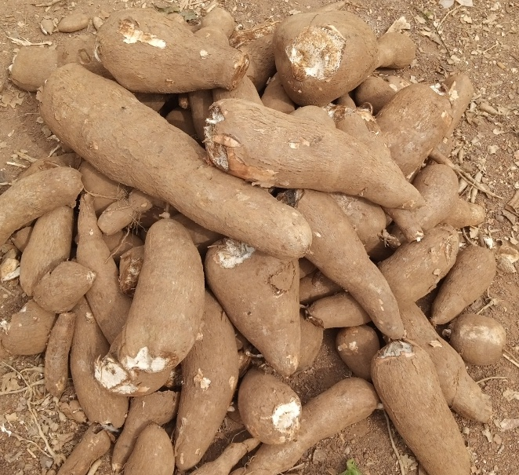**

**Fig. 2:** Cassava tubers

world’s largest cultivator of Cassava, producing about 21.06% in 2019. On a large scale, Africa contributes to about 57% of the world’s Cassava supply (Monteiro *et al.,*., 2016). Due to its ability to grow in poor soils with limited water, its availability is enhanced, making it an important feedstock in food, feed and non-food industrial production processes.

**1.5.1 Cassava starch**

Cassava starch is an odorless and fine powder that is leached from the roots and peels of Cassava plants. The starch granules from Cassava have a circular shape, with one end truncated and a clearly visible spot in the center (Thathsaranee *et al.,* 2023). Their dimensions typically range from 5 to 35 micrometers (Chisenga *et al.,* 2019). The process of producing Cassava starch usually comprises a sequence of mechanical steps, which includes activities like peeling out the outer layer and shredding the Cassava roots, separating the fibers, removing water from the starch, and then drying it (Akpa, 2012). Its composition can vary depending on factors such as the variety of the Cassava plant and the processing method used to extract the starch. However, Cassava starch on average is composed of approximately 70-80 % amylopectin and 20-30% amylose (Horstmann *et al.,* 2017). Cassava starch has several advantages over other types of starches in adhesives formulations. It has a high viscosity, which makes it an effective thickener and binder. It has a low gelatinization temperature and a low retrogradation tendency, meaning that its thickness remains consistent even after cooling (Oladunmoye *et al.,* 2014).

**1.5.2 Starch from Cassava peel**

Peels from Cassava roots are agro-waste resources discarded after peeling the tuber. It can represent 5 to 15 % of the root (Abiaziem and Ojelade, 2019). Research has proven that there is an abundant amount of starch available in Cassava peel and the physicochemical properties of this starch are comparable to starch gotten from Cassava flesh (Table 2). However, these wastes are discarded into the environment, contributing to the already existing environmental pollution. Fronza *et al.,* (2022) had also proven that the content and the properties of starch extracted from Cassava residues are within the ranges of those extracted from the flesh. The Hydrogen cyanide HCN content in Cassava peel is higher when compared to the tuber flesh (Wasistha *et al.,*, 2021). HCN is a highly toxic compound and can be identified in Cassava by its bitter taste. The high content of HCN in Cassava peels is the major reason they are not used as feeds for animals, but instead are discarded. Based on the carbohydrate content of Cassava peel, which is 50% of the weight of the peel (Susanti *et al.,* 2017), starch extracted from Cassava peels has found massive industrial utilization even in the food sector. Hence, the HCN content of the peels needs to be removed or reduced to a minimum level. To do this, the Cassava peels can be soaked, boiled or demented to remove the cyanide content. The employability rate of starch derived from Cassava peels in any application is as good as starch derived from the roots of Cassava itself (Sivamani *et al.*, 2018). This can be attributed to the reasonable amylose to amylopectin ratio, which facilitates gelatinization and contributes to high solubility and swelling power, highly desirable properties for adhesive applications (Fronza *et al.*, 2022). It is believed to contain high thermal stability, suggesting strong intermolecular and intramolecular interactions of the starch molecules which is a favourable characteristic desired in starch-based adhesives (Wasistha *et al.*, 2021).

**Table 2:** Comparative physicochemical properties and proximate compositions of

starches from Cassava roots and Cassava peels

|  |  |  |
| --- | --- | --- |
| **Starch Parameters** | **Cassava Root**  **Starch (CRS)** | **Cassava Peel Starch (CPS)** |
| **Physical Appearance** | Brilliant white | Brownish white |
| **Granular Shape** | Round | Oval |
| **Texture** | Smooth (Amorphous) | Smooth (Amorphous) |
| **Starch Yield (%)** | 80 - 90 | 26.68 – 44.99 |
| **Lipid (%)** | 0.02 0.001 | 0.15 ± 0.001 |
| **Protein (%)** | 0.37 0.01 | 0.1 ± 0.09 |
| **Ash (%)** | 0.16 0.01 | 1.29 ± 0.08 |
| **Moisture (%)** | 13.7 | 9.73 |
| **Amylose (%)** | 19.49 | 16.39 |
| **Amylopectin (%)** | 80.51 | 83.61 |

(Sources: Susanti *et al.,*, (2017); Fronza *et al.,* (2022); Souto *et al.,* (2016); [Olaleru](https://www.researchgate.net/profile/Ibikunle-Olaleru) *et al.,* (2015); [Kumar](https://www.researchgate.net/profile/Vicky-Kumar-3) *et al.,* (2020); Krolikowska *et al.,* (2022))

**1.6 Formulation of starch-based adhesives**

Starch-based adhesives are prepared based on a special property of starch which when subjected to heat; the starch undergoes a rapid increase in viscosity as the starch granules gel. The high viscosity developed at a critical temperature leads to the phenomenon referred to as *tackiness* (Roquette, 2013). Starch suspended in cold water is not effective as an adhesive due to the presence of amylose fraction, which causes the starch granules to be tightly bound in crystalline regions (Nasiri *et al.,*, 2020). These granules must have to be broken down first in order to obtain a good bonding property. The simplest method of doing this is by heating the starch granules in water (Egharevba, 2019). However, the general steps involved in the formulation of starch-based adhesives, as indicated by literatures, may include:

* **Selection of starch:** The type of starch used in the adhesive formulation depends on the application and the desired properties of the adhesive to be formulated.
* **Gelatinization of the selected starch:** To improve the properties of the starch, it is first gelatinized by heating in water or water-based solution. The gelatinization process helps to breakdown the starch granules and makes them more soluble in water.
* **Modification of starch:** Depending on the application, the starch may need to be modified to improve its adhesive properties. Different methods exist through which this can be done.
* **Enhancers:** Many other condiments may be added to the starch-based adhesive formulation to improve its flexibility, preservatives to prevent microbial growth, as well as filler to improve the quantity of the adhesive.
* **Adjustment of pH and viscosity:** To optimize the performance of the starch-based adhesive, the pH and the viscosity may be adjusted. For instance, the addition of acid or base can adjust the pH based on the interest, while the addition of water or other solvents can adjust the viscosity.
* **Quality control:** The formulated adhesive may now be tested for various properties, such as viscosity, pH, solid content and bonding strength, to ensure it meets the desired specifications.
  1. **Advantages of starch-based wood adhesives**

Starch-based adhesives offer several advantages over synthetic wood adhesives, in the following;

* **Renewability and biodegradability**: Starch-based adhesives are made from natural materials and are therefore renewable and biodegradable. This makes them a more environmentally friendly option compared to synthetic wood adhesives, which are often petroleum-based and non-biodegradable.
* **Non-toxicity**: Starch-based adhesives are generally non-toxic, making them safer for workers to handle and reducing the risk of health hazards compared to some synthetic wood adhesives that may contain harmful chemicals.
* **Low cost**: Starch-based adhesives are often more cost-effective compared to synthetic wood adhesives, especially when produced on a large scale.
* **Easy to modify**: Starch-based adhesives can be modified chemically, physically, or biologically to improve their properties for specific applications.
* **Low VOC emissions**: Starch-based adhesives typically have lower VOC (volatile organic compound) emissions compared to synthetic wood adhesives, which is beneficial for indoor air quality and overall health.
  1. **Disadvantages of starch-based adhesives**

While starch-based adhesives have many advantages, they also have some disadvantages when compared to synthetic wood adhesives. These include:

* **Water sensitivity**: Starch-based adhesives are highly sensitive to moisture and can lose their adhesive strength when exposed to water. Synthetic wood adhesives, on the other hand, are often more resistant to water and can maintain their strength even when exposed to moisture.
* **Limited shelf life**: Starch-based adhesives have a shorter shelf life compared to synthetic wood adhesives, which can lead to issues with storage and handling.
* **Longer curing time**: Starch-based adhesives typically have a longer curing time compared to synthetic wood adhesives, which can slow down the manufacturing process.
* **Lower heat resistance**: Starch-based adhesives may not be suitable for applications that require high heat resistance, as they can break down and lose their strength at high temperatures.
* **Limited bonding strength on certain substrates**: While starch-based adhesives can provide good bonding strength to many substrates, they may not be as effective on certain materials such as metals or plastics.

**1.9 Modifications of Starch-based Adhesives**

Due to the mentioned insufficiencies of starch, it is essential to utilize efficient techniques to modify starch chemically, physically, or biologically. This modification can alter the viscosity and solubility of starch and enhance other significant properties during the production of starch-based adhesives (Wang et al., 2012). Properties of starch-based adhesives that can be modified through formulation variables include: viscosity, shear strength, thermal stability, tackiness, flexibility, and water resistance. The chemical modification of starch relies on the reactivity of the glucose units that make up the starch molecules (Nawaz *et al.,* 2020). These glucose units have multiple hydroxyl groups, which make them reactive and capable of undergoing various chemical reactions. Chemical agents such as acids, alkalis, and enzymes are commonly employed in the chemical modification of starch (Egharevba, 2019). For instance, acid treatment has been utilized for many years to hydrolyze starch granules and create soluble starch (Yu *et al.,*, 2015). Hydrochloric acid, sulfuric acid, and citric acid are frequently employed to break down the glucosidic bonds within the starch molecules. This process of cleaving the bonds between the glucose monomers can result in changes to the properties of the starch. Starches that have undergone acid or alkali treatment are commonly employed in industry as preliminary steps to modify them for the production of starch adhesives. Masina *et al.,*, (2017) have outlined the different other ways of modifying starch which include; oxidation of starch, heat treatment, hydrolysis, esterification, etherification, grafting and cross-linking.

**1.9.1 Oxidation of starch**

The oxidation of starch in starch-based adhesives can occur through various mechanisms, including enzymatic and non-enzymatic processes (Vanier, *et al.,* 2017). Enzymatic oxidation of starch occurs through the action of enzymes such as glucose oxidase, which oxidizes glucose molecules in starch to form gluconic acid and hydrogen peroxide (Masina *et al.,* 2017). Non-enzymatic oxidation of starch occurs through the action of various chemical agents, such as potassium permanganate, sodium hypochlorite, persulfate of bromine, potassium and ammonia (Lewicka, 2015). The process of oxidation can lead to a partial breakdown of natural starch, which generates carboxylic or aldehyde groups by oxidizing primary and secondary hydroxyl (-OH) groups (Egharevba, 2019). This is because the glycosidic bonds in starch can be attacked by the oxidizing agent, causing them to hydrolyze and form alcohol (-OH) groups or/and C-C bonds of the glucose unit. .The oxidation of starch in starch-based adhesives can lead to several changes in the adhesive properties of the starch, including a reduction in viscosity (Zhao *et al.,* 2018), an increase in adhesive strength (Li *et al.*, 2020), and a decrease in the gelatinization temperature. These changes occur due to the breakdown of starch molecules into smaller fragments, which can enhance the interactions between the adhesive and the substrate.

**1.9.2 Hydrolysis of starch**

Hydrolysis of starch is an addition reaction which can be carried out either through enzymatic or chemical process. Enzymatic hydrolysis uses the enzyme malto-amylase to achieve hydrolysis (Hartline, 2023). While chemical hydrolysis involves breaking down the starch molecule through heating in the presence of water, dilute hydrochloric acid or hydroxide of alkali metals. Acid hydrolysis is called roasting which results in acid modified starch (Nawaz *et al.,*, 2020). Using sodium or potassium hydroxide in starch treatment, results in alkaline starch. During the hydrolysis process, the starch molecule is broken down into smaller fragments called dextrins (Foist, 2022), which have improved solubility and adhesive properties compared to the original starch molecule. Hydrolyzed starch in the production of starch-based adhesives has been reported to have improved their properties, such as reducing their viscosity and increasing their adhesive strength.

**1.9.3 Esterification of starch**

Esterification is a highly effective method for modifying starch chemically. It involves a chemical reaction between the alcohol group (-OH) of the glucose unit and either the carboxylic acid group (-COOH) of fatty acids or the -COCl of fatty acid chlorides (Fig. 6), in the presence of basic catalysts such as potassium carbonate, sodium hydroxide, and sodium hydrogen phosphate or acid catalysts such as hydrochloric acid, sulfuric acid, and p-toluene sulfuric acid (Lewicka *et al.,*, 2015). It can be carried out by means of acylation, acetylation, alkylation, transeterification and succinylation (Egharevba, 2019). The essence of esterification is to introduce more lipophilic groups into the starch molecule by replacing the hydroxyl groups in starch with more bulky functional groups of free fatty acids or their derivatives, making it more lipophilic and hydrophobic in nature. It weakens the inter-molecular bonding that holds the granules together and hence alter the granule shape and sizes as well as other functional properties of the starch such as better water resistance (Sun *et al.,* 2018), increased strength (Wang *et al.,* 2019), and improved stability (Xu *et al.,* 2016).

**1.9.4 Etherification of starch**

Similar to esterification, etherification is a process that primarily involves incorporating lipophilic alkyl groups into the starch molecules. This modification reduces the hydrophilicity of the starch and the level of inter- and intra-molecular hydrogen bonding between the molecules (Masina *et al.,* 2017). The etherification process typically involves reacting the starch molecule with an etherifying agent, such as ethylene oxide or propylene oxide, in the presence of a catalyst. These epoxides are very reactive, and the hydroxyl (OH) groups of starch molecules attack the epoxide ring, causing cleavage of the carbon-oxygen (C-O) bonds of the epoxide. Etherification reaction yields diol products which are subsequently linked to the starch chains, resulting in the formation of lipophilic alkyl groups (Watcharakitti *et al.,*, 2022). This process increases the hydrophobicity of the starch, enhancing its water resistance (Lamaming *et al.,* 2020).

**1.9.5 Grafting method**

Grafting is a chemical process used to modify starch molecules by attaching side chains or branches with the desirable properties unto the main polymer chain of starch molecule (Ulker and Hiziroglu, 2020). During the process of grafting, the starch molecules are modified by reacting them with monomers or oligomers, which are attached to the starch molecule to form branches or side chains on the Cl–C2 end groups and C2–C3 glycol groups of the glucose units in the starch molecule (Watcharakitti *et al.,* 2022). It is worthy of note that the crystallinity and the biodegradability of the starch remains the same even after grafting. Glycidyl Methacrylate (GMA) grafted unto Cassava starch has been reported to have improved in its hydrophobicity and shear strength by 163% higher than unmodified starch adhesive (Chen *et al.,* 2022). The most common monomer employed in grafting of starch is vinyl acetate monomer (PVAc). It has been proven to have increased the shear strength of a corn starch derived adhesive by 59.4% in dry state and 321% in wet state, and its water resistance by 61.1%.

**1.9.6 Cross-Linking method**

Cross-linking of the starch polymer involves the formation of inter- and intra-molecular non-polar bonds between random hydroxyl groups at different locations in the starch molecule (Nasiri *et al.,*, 2020). During cross-linking, one or combination of the following methods are applied in order to achieve the desired quality in the starch molecule; hydrolysis, oxidation (Su *et al.,*, 2022), esterification (Sun *et al.,*, 2018) and etherification (Lamaming *et al.,*, 2020). Cross-linking reagents usually employed are; Epichlorohydrin monosodium phosphate, phosphoryl trichloride, sodium trimetaphosphate, sodium tripolyphosphate, a mixture of adipic and acetic anhydride, and vinyl chloride. Cross-linked starch molecules have a higher molecular weight and are more resistant to water and heat, making them useful for adhesive applications (Vineeth *et al.,*, 2021).

**1.10 Characterisation of adhesives**

Characterisation is the process of determining and describing the properties and behavior of a material or substance, often through various analytical techniques and tests. In the case of adhesives, characterisation involves assessing the physical, chemical, and mechanical properties of the adhesive to understand how it behaves and performs under different conditions (Poulis *et al.,*, 2022). Some of the common methods used for characterizing adhesives include; Fourier Transform Infrared Spectroscopy (FTIR), Scanning Electron Microscopy (SEM) and Thermogravimetric Analysis (TGA).

**1.10.1 Fourier Transform Infrared Spectroscopy (FTIR)**

Fourier Transform Infrared Spectroscopy (FTIR) is a common technique used for analyzing the chemical compositions of adhesives. It provides information on the functional groups present in the adhesive and works by measuring the absorption of infrared radiation by the sample, which generates a spectrum that can be used to identify the functional groups and chemical bonds present in the adhesive (Hirsh, 2022). FTIR can be used to analyze the curing process of adhesives. By taking spectra at different time points during the curing process, changes in the intensity and position of the peaks in the spectrum can be observed, indicating the progression of the curing reaction (Lowry and Weesner, 2011). In starch-based adhesives, FTIR is used to analyze the degree of gelatinization of the starch, which can affect the viscosity and adhesive properties of the adhesive (Wang *et al.,*, 2012). FTIR can as well be employed in monitoring the extent of cross-linking of an adhesive (Chen *et al.,*, 2022).

**1.10.2 Scanning Electron Microscopy (SEM)**

Scanning Electron Microscopy (SEM) is a powerful imaging technique used in examining the surface of adhesives at high magnifications. It uses an electron beam to scan the surface of a sample, generating detailed images that can provide valuable information on the morphology and microstructure of an adhesive (Hamidu *et al.,*, 2019). Analysis on the surface topography of an adhesive which include features such as roughness, porosity, and defects, as well as the microstructure of the adhesive, including the distribution and size of particles or fibers within the adhesive, which can affect its strength and stiffness are all carried out through SEM (El *et al.,*, 2012). SEM can also be used to analyze the adhesive-substrate interface, providing information on the quality of the bond and the presence of any defects or failures, by examining the interface at high magnification, and identifying the nature of the bond, whether it is a mechanical or chemical bond, and the presence of any voids or inclusions that may affect the bond strength.

**1.10.3 Thermogravimetric Analysis (TGA)**

This technique is used to study the thermal stability and decomposition behavior of adhesives when exposed to changes in temperature (Srivastava *et al.,*, 2020). It involves measuring the weight loss of the sample as it is heated in a controlled atmosphere, typically under a flow of nitrogen or air (Díaz-Díaz *et al.,*, 2020). In the case of starch-based adhesives, TGA provides information on the thermal stability of the starch and the extent of cross-linking, which can affect the adhesive properties, determining the decomposition temperature of the adhesive, which can help to optimize the formulation for specific applications. The TGA curve of a starch-based adhesive typically shows several stages of weight loss corresponding to different thermal events (Xing *et al.,* 2018). The initial weight loss is due to the loss of moisture from the adhesive, followed by the decomposition of the starch and the cross-linking agent. The final stage of weight loss corresponds to the decomposition of any remaining organic components in the adhesive. TGA can also be used in combination with other techniques, such as FTIR, to gain a more complete understanding of the chemical and thermal properties of the adhesive.

**1.11 Process parameters**

The formulation of starch-based adhesives involves several process parameters that can affect the quality and performance of the adhesive. The two major parameters to look out for during the formulation of a starch-based wood adhesive are the pH and temperature.

**1.11.1 pH of starch-based adhesives**

The pH range of 4.5 to 6.5 is typically recommended for starch-based adhesives because it is within the range of pH where starch is most stable and has the best adhesive properties (Henley, 2014). Starch molecules are composed of both amylose and amylopectin, which are held together by hydrogen bonds (Mehmood, 2019). The stability of these bonds can be affected by pH, which can in turn affect the properties of the adhesive. At a pH below 4.5, the hydrogen bonds in the starch molecule can break down, leading to a loss of viscosity and adhesive properties (Olayinka, 2015). At a pH above 6.5, the starch can become hydrolyzed, resulting in a loss of viscosity and adhesive properties. Therefore, a pH range of 4.5 to 6.5 is recommended to maintain the stability and adhesive properties of the starch-based adhesive.

**1.11.2 Temperature**

Temperature is an important parameter during the process of formulating starch adhesives. The temperature at which the starch is cooked or gelatinized can affect the adhesive's properties. Higher temperatures can lead to faster gelatinization and higher adhesive strength, but can also lead to increased viscosity and decreased adhesion. Literature has revealed that temperature has effects on the viscosity, bonding strength, and density of starch-based adhesives. As the temperature of a starch-based adhesive rises, it becomes less dense and flows more easily. This results in a reduction in its resistance to flow, which means that its viscosity is expected to decrease with increasing temperature. The result of Akpa (2012) experiment on the effect of temperature on the viscosity of a Cassava derived starch adhesive predicts this trend as true, where the viscosity of the adhesive reduces as temperature at which the adhesive is produced increases at all borax concentrations. Because of the gelatinization of the starch, the bond strength of a starch-based adhesive starts increasing just before gelatinization temperature is reached, after which there is a decline as a result of a completion of gelatinization. Yu *et al.,*, (2015) conducted a study which illustrated the effect of temperature on the bond strength of a corn derived adhesive. The result suggests that, due to the amount of free hydroxyl groups present on the starch molecular chains, when the treatment temperature is increased, the bond strength will first increase, and then subsequently decreases. The bond strength value stopped increasing as the temperature exceeded 55 °C. Increasing the temperature at which the adhesive is produced causes the adhesive to swell resulting in an increase in the volume of the adhesive, it also causes a reduction in the water content, resulting in a reduction in mass (Bhambure and Mallick, 2012). Hence, the influence of temperature on the density of the adhesive is a balance between these two dynamics.

**1.12 Adhesives testing**

Adhesive testing is an important step in the course of its production to evaluate its durability and reliability in bonding wide range of materials over a long-term period (Besley, n.d). It provides assurance against bonding failure which could be as a result of abnormal amount of additives, inadequate curing, contamination, unprepared adherent and thermal instability (Forza, 2022). Adhesive testing can be performed on dry or wet adhesives and in hot or ambient temperatures, which can be determined by the nature of test to be carried out. Various tests carried out on adhesives include; colour, odour, aging, solid content, viscosity, gelatinization temperature, pH, stability and bond strength.

**1.13 Problem statement**

The depletion of fossil fuel resources and growing environmental concerns, such as pollution, has prompted the chemical industry to explore alternative, biodegradable resources that are cost-effective and less toxic. To meet the demand for resource consumption without compromising the environment and human health, there is a search for renewable resources and alternative production processes. The wood industry has traditionally relied on synthetic thermosetting adhesives, such as urea-formaldehyde, phenol-formaldehyde, and melamine-urea-formaldehyde, but the use of formaldehyde-based adhesives presents sustainability issues related to raw materials and final products, price fluctuations of fossil resources, increasingly stringent legislation, and formaldehyde emissions, especially in indoor applications. To address these issues, the industry is transitioning to greener wood adhesives based on sustainable bio-polymers such as starch. However, significant challenges remain in developing bio-based adhesives that meet all requirements for both indoor and outdoor wood applications, particularly in the area of water resistance. This is because the inherent hydrophilic nature of most bio-polymers needs to be modified to ensure that the final adhesive bond can withstand humidity and water effectively.

**1.14 Aim and objectives of study**

This research aimed at formulating and characterizing formaldehyde-free, high-performing and relatively cheap wood adhesive from Cassava starch.

**The following are the specific objectives of the study;**

* To formulate wood adhesives from both Cassava roots and Cassava peels.
* To characterize the physical and chemical properties of the prepared adhesives.
* To test the bonding strengths (shear strength) of the prepared adhesives on plywood.
* To study the comparison between the bonding strengths of the two adhesives

**1.15 Scope of study**

This study only focused on the preparation of wood adhesive from Cassava starch, even as other starch sources could serve same purpose. It embodies the processes involved in the extraction of the starch used in the adhesive formulation from Cassava roots and peels, the preparation of wood adhesives from the Cassava root and the Cassava peel starches and the characterisation of the adhesives formulated. It also covers the various tests carried out on the adhesive, such as; pH test, viscosity, as well the bond strength.

**1.16 Justification**

Due to the limited raw materials and the negative impact of synthetic compounds on both human health and environment, natural and renewable resources represent an attractive alternative for the production of adhesives. There is a rapid increase in interest by researchers to transform bio-based polymers such as lignin-derivatives, starch, tannins, soy and xylan to adhesives due to their low cost, abundance in nature and biogradability. Therefore, this research was carried out on starch derived wood adhesives to emphasize on its relative inexpensiveness, non-toxicity and the necessity in obtaining environmentally safe and high-quality adhesives that best fit their applicability domains.

**1.17 Limitation**

The major limiting factor encountered during the course of this research was time. Though, there was a financial factor and availability of characterisation facilities.

**CHAPTER TWO**

**LITERATURE REVIEW**

**2.1 Review of related literatures**

The use of synthetic compounds in the production of adhesives has negative impacts on both human health and environment, and with the limited availability of raw materials due to the depleting fossil resources, researchers have grown enormous interest in natural and renewable resources, particularly starch, as a viable alternative.

Zhang *et al.,*. (2015) developed a highly efficient method for preparing high performing starch-based wood adhesives using hydrogen peroxide (H₂O₂) as an oxidant, a silane coupling agent as a cross-linking agent and an olefin monomer as co-monomer, the effects of various parameters on the shear strength of the adhesive were investigated. Analyses on the synthesized adhesive as well as the fractures on the bonded joints of the wood composite were carried out using Fourier transform infrared (FTIR) spectroscopy, scanning electron microscopy (SEM) and thermogravimetry. The results indicated that the bonding strength of the formulated starch-based wood adhesive reached 7.88MPa in dry state and 4.09MPa in wet state which was attributed to the modified microstructure of the adhesive due to graft copolymerization.

Akpa (2012) improved on the properties of Cassava starch-based adhesive synthesized by investigating the effects of temperature, mass concentration of the viscosity enhancer (borax) and gelatinization modifier (acidic, hydrogen chloride acid (HCl) and basic sodium hydroxide (NaOH)) and its concentration on the properties (viscosity, density and pH) of the adhesive as well as the effect of the gelatinization modifier (HCL and NaOH) on the drying time and bond strength of the adhesive. This work showed that there are wide range of conditions for producing starch-based adhesives for diverse applications and required properties. The results indicated that adhesives produced with sodium hydroxide as its gelatinization modifier had a stronger bond and a maximum drying time of 7.20 minutes compared to an adhesive produced with hydrogen chloride acid as its gelatinization enhancer with a drying time of 4.16 minutes.

Benhamou *et al.,*, (2022) synthesized corn starch mimosa tannin bio-adhesive where carboxylated cellulose nanocrystals (C-CNCs) from alfa fibres were evaluated, for the first time, as a binder in a starch-based adhesive for manufacturing wood product. The C-CNCs were prepared through a hydrolysis process by means of mixed acid system (citric acid + hydrochloric acid). The resultant effect of 0.5%, 1%, 1.5% and 2% fibre contents on the mechanical properties of the prepared composites were assessed. By studying the physical properties and the contact angle measurement between the panels and the adhesive, it was found that 1% of C-CNCs led to a significant strength and water resistance improvement to the synthesized starch adhesive.

By using Cassava starch and polyvinyl alcohol (PVOH) blends, Jiang *et al.,*, (2019) developed an environmentally friendly starch-based adhesive. Varying amounts of polymethylene polyphenylene isocyanate (PAPI) were used as cross-linking agent to improve the hydrophobicity of the adhesive. The mechanical and physical properties of the adhesive were evaluated; the shear stress was measured by a mechanical testing machine while Fourier transform infrared (FTIR) spectroscopy, Scanning electron microscopy (SEM) and thermogravimetric analysis (TGA) were used to characterized the properties of the synthesized starch-based adhesive and the cured products. The findings stated that using PVOH with a low degree of alcoholysis was much better than using PVOH with a high alcoholysis. With 7wt% of PVOH₁ (PVOH with a low alcoholysis), the shear strength of the adhesive reached 7.77 MPa in dry state and 1.36MPa in wet state and this was attributed to the reactive hydrogen in the wood and the Cassava starch.

Zia-ud-Din *et al.,* (2018) designed and demonstrated the enhancement of corn starch-based wood adhesive using two co-monomers; vinyl acetate (VAc) and butyl acrylate (BA), which promoted the graft copolymerization on the corn starch. The influence of the addition of the co-monomers on the properties of the formulated adhesive were evaluated and the results showed that the addition of the co-monomers in the ratio of VAC/BA 6:4 (v/v, volume basic of VAc), improved the shear strength of the adhesive to 6.68MPa in dry state and 3.32MPa in wet state. Characterisation of the graft copolymerized wood adhesive were carried out with Fourier transform infrared (FTIR) spectroscopy, ¹H-nuclear magnetic resonance (¹H-NMR), Scanning Electron Microscopy (SEM) and Transmission Electron Microscopy (TEM), which all indicated a successful graft copolymerization of the corn starch.

Otoikhian *et al.,* (2014) developed two (2) different formulations (formulation A and B) of Cassava starch adhesives and the products were analyzed. A sample from formulation A with more quantity of materials was applied on two pieces of paper and allowed to stay overnight, the next morning it was joined and adhered strongly. Second sample from formulation B, with little quantity of materials was applied to the surface of the two planks and allowed to stay overnight. Result showed that formulation A spread the least and that the spread ability of adhesive varied with starch water ratio. The effect of Nitrosol cellulose (as a thickener) was determined from the results of the tests done on the formulations. Hence, increase in viscosity is proportional to the starch concentrations. Also increase in temperature was found to have increased the gelatinization strength until the gelatinization temperature was exceeded.

Xing *et al.,* (2018) worked on the development and characterisation of a new and environmentally-friendly wood adhesive using Cassava starch and bio-oil derived from the fast pyrolysis of larch sawdust. The characterisation of the structural and thermal decomposition of the formulated adhesive using Fourier transform infrared (FTIR), Scanning electron microscopy (SEM), Atomic Force Microscopy (AFM) and Thermogravimetric Analysis (TGA) showed that the improved performance of the bio-oil-starch (BOS) adhesive was supported by its strengthened molecular structure and enhanced thermal stability. Compared with natural starch-based wood adhesive, the BOS adhesive exhibited better storage stability with a storage period extension of 13 to 55 days; higher shear strength of 17.4% in dry state and 50.9% in wet state as well as its water resistance by 10%.

Basta *et al.,* (2013) research added value to the economy and reduced the environmental impact of waste disposal by using rice straw in an eco-polyalcohol polymer-based adhesive system. The polyalcohol polymer-based adhesive system was synthesized by blending, at a temperature of 75ºC, corn starch and polyvinyl alcohol PVOH), as a natural polyalcohol polymer and as a synthetic polyalcohol respectively. The bond strength of the synthesized adhesive was assessed in comparison with the predominant synthetic wood adhesive; Urea formaldehyde. The mechanical and physical properties of the synthesized adhesive were evaluated from the wood composited produced, which showed improved performance over urea formaldehyde as the bonding strength test result gave 9.8N/mm², the modulus of rupture (MOR) gave 31N/mm² and the internal bond strength as 0.49N/mm².

Sun *et al.,* (2016) prepared a high performing Cassava starch-based wood adhesive using hydrogen peroxide as an oxidant, acrylamide as a hard co-monomer, butyl acrylate (BA) as a soft co-monomer and an organic siloxane as cross-linking agent. The effects of various parameters on the shear strength, the water resistance and the viscosity of the adhesive were studied. The organic siloxane added was found to have reduced the content of hydroxyl on the starch molecules, which resultantly improved the bonding strength, the water resistance as well as the shear strength reaching 6.11MPa in dry state and 3.05MPa in wet state.

Having improved on the properties of Cassava starch by hydrolysis, oxidation and dextrinization, Opara *et al.,* (2017) produced various adhesives for several purposes incorporating plasticizers and tackifiers. Performance tests such as shear strength, viscosity, drying time, colour and stability as well as cost analysis were carried out on the synthesized adhesives. The results showed that these adhesives generally have good bonding strength on wood, cardboard, paper and leather materials. However, adhesives produced from hydrolyzed and oxidized starch showed exceptionally good bonding properties.

**CHAPTER THREE**

**MATERIALS AND METHODS**

**3.1 Materials**

The primary component of this experiment is starch, from Cassava roots (as CRS) and Cassava peels (as CPS). The Cassava tubers used in the experiment were procured from Nwakpu market in Ndufu-Alike Ikwo LGA, Ebonyi state.

**3.1.1 Reagents**

The reagents employed in the formulation of both Cassava root starch adhesive (CRSA) and Cassava peel starch adhesive (CPSA) which include; sodium hydroxide (NaOH) as gelatinization facilitator, Borax as cross-linking agent, polyvinyl acetate (PVAc) as tackifier, glycerin as plasticizer, Hydrochloric acid (HCl) as pH modifier and distilled water were all procured in Abakaliki, Ebonyi state.

**3.1.2 Apparatus**

The following equipment and Laboratory apparatus were used during the course of this experiment; OHAUS Adventurerᵀᵐ precision weighing balance, graduated beakers, steel pan, stirrer, spatula, LPG burner, NDJ-5S digital viscometer, universal testing machine, Cary 360 FTIR spectrometer, SEM analyzer and Mettler Toledo thermal gravimetric analyzer.

**3.2 Methods**

**3.2.1 Sample preparation: starch extraction**

The first step taken in the formulation of the adhesive samples, CRSA and CPSA, was the extraction of the starches from the Cassava roots and the peels. The Cassava starches were primarily extracted through the wet milling of fresh Cassava and its peels. The extraction procedure of both CR and CP starches were carried out as outlined in Fig. 3. The Cassava tubers were peeled, washed and cut into smaller sizes in preparation for milling, while the peels were collected and pressure washed in order to get rid of sand associated with

Cassava Roots

Peeling

Washing

Wet milling

Mixing with water

Screening (filtering)

Settling

Dewatering

Drying

Milling

Dry powdery Cassava Starch

**Fig. 3:** Production of Cassava starch

the outer skin layer (brownish in colour) and also prepared for milling. The prepared Cassava roots and peels were milled into emulsion and then sieved with a cotton screen while the fibre was retained. The retained fibres were washed repeatedly for about three to four times with distilled water on the screen in order to wash off the starch effectively. The filtered starch was allowed to coagulate after which the water decanted and the starch sundried for approximately six hours. Clumped starches were obtained (Fig. 4), white for Cassava roots and brownish white for Cassava peels and were subsequently milled to powder. The powdered starches obtained were stored in an air tight container to prevent contamination and moisture.

**3.2.2 Formulation of CRSA and CPSA adhesives**

Both CRSA and CPSA were formulated using the same formula as stipulated in Table 2. Distilled water, 500 mL, was added into a beaker containing 100g of each sample (CRSA and CPSA) and was mixed together to obtain a watery solution. The solution was heated at a low temperature of 45°C to aid the dissolution. NaCl pellets (0.5g) were added into the mixture and the mixture stirred continuously until gelling of the starch was completed. Borax (1g), dissolved in 50mL of water was added into the cooking starch mixture. The mixture was continuously stirred until gelling becomes complete and the mixture becomes sticky. Then, 5mL of PVAc and 6mL of glycerin were added to the mixture to enhance the viscosity and increase the flexibility of the resulting adhesive. To modify the pH of the adhesive, 0.1M of HCl was diluted in 50mL of water and added slowly while the mixture was continuously stirred into a smooth and homogenous consistency. The acidity level obtained for both adhesives was between 5.5– 6.5, which is of standard for starch-based adhesives (Henley, 2014).

**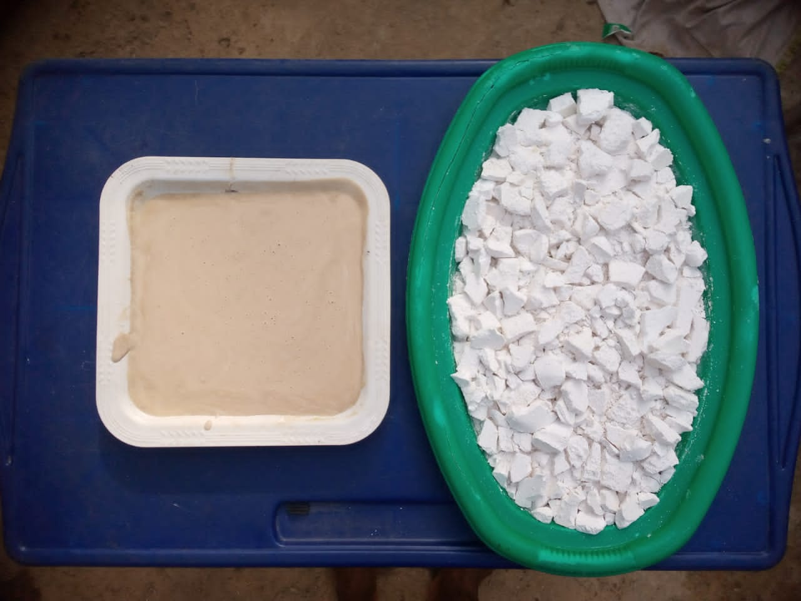**

**Fig. 4:** Extracted starch from (a) Cassava roots, and (b) Cassava peels

**Table 3:** Formulation of CRSA and CSPA

|  |  |  |
| --- | --- | --- |
| **Reagents** | **Quantity** | **Unit** |
| Starch | 100 | g |
| NaOH | 0.5 | g |
| Borax solution | 0.02 | g/mL |
| PVAc | 5 | mL |
| Glycerin | 6 | mL |
| Dilute HCl | 2 | mL |

**3.2.3 Wood specimen preparation**

For both CRSA and CPSA, thirteen sheets of plywood board each, were fabricated by applying the respective adhesives to the surface (double sides) of the plywood. The sheets were stacked on each other and pressed down in order to obtain a wood board for each adhesive as shown in Fig. 5. After that, the sheer strength of both adhesives will be subsequently obtained.

**3.3 Physical characterisation**

In order to determine the quality of the adhesives prepared, the adhesives were characterized physically by analyzing their pH values, viscosity, colour, curing time and bonding strength, while comparing the similarities between them and other commercial adhesives.

**3.3.1 pH measurement**

Using a pocket pH meter, the pH of both CRSA and CPSA were measured in their wet states. The pH meter was placed in a buffer solution to normalize the meter at 7, after which it was dipped in each adhesive samples in such a way that they come in contact with the pH meter probe. The measurements were carried out three (3) times and the average was taken for each sample.

**3.3.2 Viscosity measurement**

The viscosity was measured using a NDJ-5S rotational viscometer (Ping XuanShnghai Scientific Instrument Co. Shanghai, China) at 25 oC with a rotor at 60 rpm, 06 rpm, 12rpm and 30 rpm according to the standard ASTM D1084-16 (2021).

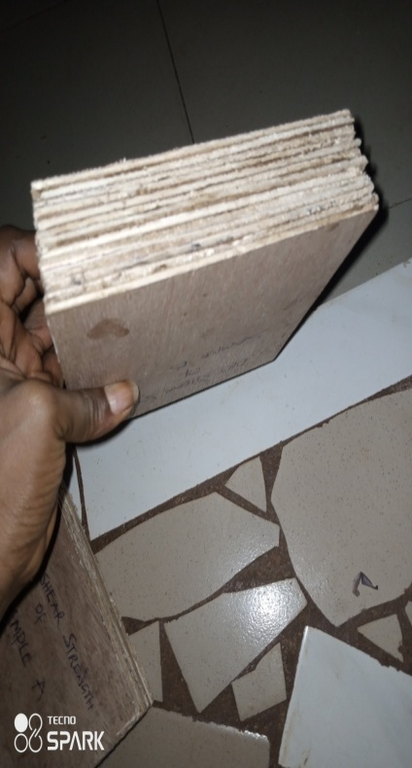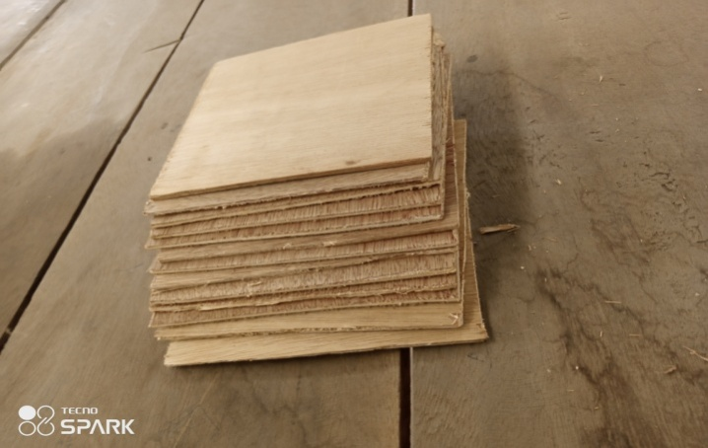

**Apply Adhesive**

**Fig. 5:** Preparation of wood specimen

**3.3.3 Curing time** **and shear strength test**

The shear strength of the adhesives each was determined using a WDT-10 shear strength analyser according to standard ASTM D905 (2013). A set dimension of 150 x 150 x 5 mm squarely cut pieces of plywood sheets totaling thirteen in number for each sample was used. Starch adhesive was smeared on double sides and the blocks were pressed at 1 MPa. After removing the pressure, the specimens were stored at room temperature for 48 h in order to determine the cure time and before testing the dry shear strength. To obtain the wet shear strength of each of the adhesives, some specimens were soaked at 25 oC for 6 hrs. The shear strength was then tested. All tests were repeated three times, and average values were calculated according to the equation:

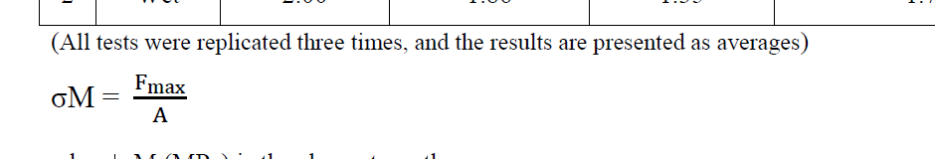

Where;

*σ*M = is the shear strength in (MPa)

*F*max = is the observed maximum failing load in (N)

*A =* is the bonding surface of the sample in (mm2).

**3.4 Chemical characterisation and thermal analysis**

To analyze the functional compositions and thermal stability of the both CRSA and CPSA adhesives, FTIR and TGA analyses were carried out.

**3.4.1 Fourier Transform Infrared (FTIR) Spectroscopy**

The infrared spectra of each adhesive samples (CRSA and CPSA) were analysed with a Cary 630 FTIR spectrometer (Cary 630 ZnSe Engine, Agilent Tech, Malaysia) to examine the changes in the chemical structure of the starch adhesives. The samples were tested in the wet state and the FTIR spectra were recorded over a wave number range between 4000 and 650cmˉ ˡ at a resolution of 4cmˉ ˡ for 32scans.

**3.4.2 Thermogravimetric Analysis (TGA)**

Thermal degradation characteristics of the Cassava starch based adhesive and Cassava waste starch based adhesive samples were studied under nitrogen atmosphere using Thermal Gravimetric Analyser (Mettler Toledo TGA/DSC) connected to power unit 240V, 16A. High purity nitrogen (99.95 %) was used as carrier gas controlled by gas flow meter. This was fed to thermo gravimetric analyser with flow rate of 50 mL/min. A water bath of mini-chiller was connected to the analyser to circulate cooling water. Three plus (3+) star System software was utilized to acquire, store and analyse the data in desktop computer. A sample of 11.600 ± 0.1 mg was loaded in a crucible in the furnace and heated from 40 °C to 600 °C at heating rate of 10 °C/min. As the heating rate variation changed the peak temperature also increased which led to change in the amount of the MSW in the crucible. The calculated thermo-gravimetric output from 3+ star software was obtained as thermal decomposition profile; thermo-gravimetric and differential thermo-gravimetric curves. The thermo-gravimetric (TG) and differential thermo-gravimetric (DTG) curves were recorded.

**CHAPTER FOUR**

**RESULTS AND DICUSSION**

**4.1 Discussion of results obtained**

The prepared adhesives can be seen in fig. 6. The results obtained from the tests conducted on both CRSA and CPSA are presented and discussed with respect to the comparison between the two adhesives.

**4.1.1 pH measurement**

The pH measurements for both CRSA and CPSA are shown in Table 4, where three (3) different pH readings and the average were taken for the both adhesives. Representing the pH average values pictographically (Fig. 7), it be can be seen that CRSA and CPSA are both acidic. CRSA was more acidic than CPSA with pH value of 5.4 and 6.6 for CPSA. Since both adhesives were produced from the same starch source, using the same formula and method of preparation, the reason for the variation in pH values can only be attributed to the various compositions of the starches and impurities. However, acidity levels of both adhesives were compatible with the wood’s surface, allowing sufficient wettability and good bonding between the two wood surfaces. Also, the low pH value of CRSA contributed to the thick consistency of the adhesive, while the high pH value of CPSA contributed to its thin consistency. These findings are in line with the findings of Glavas (2011), whose formulated starch-based adhesives had pH values of range 5 – 6.

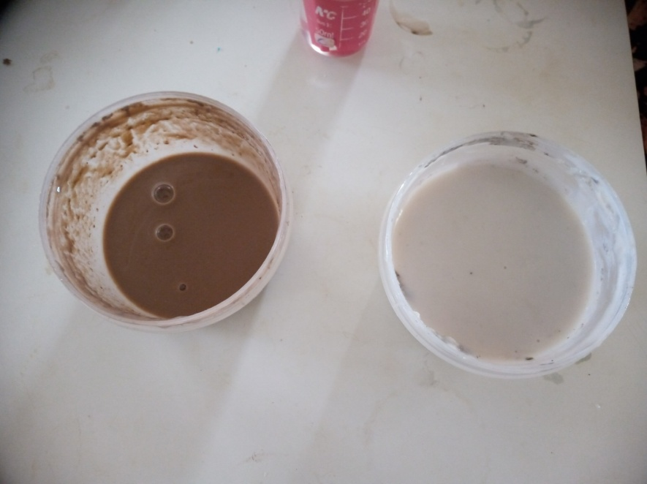

**Fig. 6:** Prepared adhesives, (a) CRSA (b) CPSA

**Table 4:** pH values of the prepared adhesives

|  |  |  |  |  |
| --- | --- | --- | --- | --- |
|  | **pH₁** | **pH₂** | **pH₃** | **Average** |
| **CRSA** | 5.4 | 5.5 | 5.3 | 5.4 |
| **CPSA** | 6.6 | 6.6 | 6.6 | 6.6 |

**Fig. 7:** Pictograph of the pH of CRSA and CPSA

**4.1.2 Viscosity**

The result of the viscosity measurements of both CRSA and CPSA is shown in Table 5. According to the data, both CRSA and CPSA showed an increase in viscosity as the rotational speed increases, suggesting that both adhesives are shear-rate dependent, meaning they became more viscous as the applied shear rate (rotational speed) increases. However, CRSA generally exhibited higher viscosity values compared to CPSA at all tested rotational speeds which indicated that it is more resistant to flow than CPSA. From a graphical representation of these viscosity results (fig. 8), it can be observed that at 6 rpm, 12 rpm and 30 rpm speeds, CRSA exhibited increasing higher viscosities when compared to CPSA, with values; 4116 mpa.s, 10,265 mpa.s and 20,425 mpa.s respectively. While CPSA, at 6 rpm, 12 rpm and 30 rpm exhibited viscosities of values; 1904.5 mpa.s, 2799.5 mpa.s and 6858 mpa.s respectively. However, as the rotor speed increased to 60 rpm, it was observed that both CRSA and CPSA exhibited drastic decrease in viscosity at an almost uniform rate. This behavioural pattern is observed in pseudo-plastic fluids (Ojewumi *et al.,*, 2021), where there is decline in viscosity as the shear rate increases. Similarly, the rheological behaviour of these adhesives may be attributed to complexity in their molecular structures at higher shear rate.

**4.1.3 Curing time and shear Strength Test**

CRSA exhibited a shorter curing time of 12 hrs compared to CPSA, which required 15 hrs to cure. Curing time represents the duration required for the adhesive to reach its optimal bonding strength and performance. The shorter curing time of CRSA suggests a faster bonding process, which can be advantageous for time-sensitive applications or in situations where faster assembly is desired.

**Table 5:** Viscosity measurement of CRSA and CPSA

|  |  |  |  |  |  |  |
| --- | --- | --- | --- | --- | --- | --- |
|  | **Shear Rate** | | | | | |
| **6**  **(rpm)** | | **12**  **(rpm)** | **30**  **(rpm)** | **60**  **(rpm)** | |
| **CRSA (mpa.s)** | 4116 | 10,265 | | 20,425 | | 2089.5 |
| **CPSA (mpa.s)** | 1904.5 | 2799.5 | | 6858 | | 1518 |

**Fig. 8:** Effect of shear rate on the viscosity of CRSA and CPSA

The shear strength test was conducted to assess the amount of force needed to separate the bonded wood specimen and to evaluate how the adhesive bond between the woods reacts under the applied stress. The result of the shear strength test can be seen in Table 6. Each stage of the strength test took a testing speed of 2 mm/min. From the projection in Fig. 9, the wood specimen bonded with CRSA at 25 °C exhibited an average shear strength of 7.15 MPa in dry state, indicating a relatively stronger bond than CPSA with an average shear strength of 4.38 MPa. This can be attributed to the presence of hydroxyl in the adhesives. The presence of higher amount of available hydroxyl group strengthens the cohesive force between the adhesives and their bond strengths (Baini *et al.,*, 2020). Similarly, in wet states, CRSA recorded an average wet shear strength of 3.47 MPa and CPSA, an average shear strength of 1.73 MPa which are far above the required shear stress to be withstood by an adhesive, 1.2 MPa (Astrouski *et al.,*, 2022). However, the trend can be compared to a similar study by Zhang *et al*., (2015) whose formulated starch-based adhesive presented a shear strength of 7.88 MPa in dry state and 4.09 MPa in wet state. Consequently, the result suggests that CRSA generally provides stronger bonding properties than CPSA in both dry and wet states.

Overall, the summary of physico-mechanical characterisation of both CRSA and CPSA can be seen in Table 7.

**Table 6:** Shear test result of CRSA and CPSA

|  |  |  |  |  |  |  |  |  |
| --- | --- | --- | --- | --- | --- | --- | --- | --- |
|  | **DRY TEST** | | | | **WET TEST** | | | |
| **1st** | **2nd** | **3rd** | **Average** | **1st** | **2nd** | **3rd** | **Average** |
| **CRSA** | 7.56 | 6.85 | 7.05 | 7.15 | 4.00 | 3.26 | 3.15 | 3.47 |
| **CPSA** | 4.56 | 4.85 | 3.74 | 4.38 | 2.00 | 1.86 | 1.35 | 1.73 |

**Fig. 9:** Shear strength projection for both CRSA and CPSA

**Table 7:** Summary of thephysico-mechanical characterisation of prepared adhesives

|  |  |  |  |
| --- | --- | --- | --- |
| **Parameters** | **CRSA** | **CPSA** | **Unit** |
| Colour | white | white | - |
| pH | 5.4 | 6.6 | - |
| Viscosity at 25 °C and 60 rpm | 2089.5 | 1518 | mpa.s |
| Cure time on wood | 12 | 15 | hrs |
| Cure time on paper | 7 | 10 | min |
| Bonding strength  in dry state | 7.15 | 4.38 | MPa |
| Bonding strength  in wet state | 3.47 | 1.73 | MPa |

**4.1.4 Fourier Transform Infrared (FTIR) Spectroscopy**

The comparison between the FTIR spectra of Cassava root starch adhesive (CRSA) and Cassava peel starch adhesive (CPSA) is shown in the Fig. 10 and 11 respectively. A quick look at the two results would suggest an exact same spectrum. However, the broad band observed between 3500 – 3200 was exhibited by both spectra, which is attributed to the presence of –OH groups of free hydroxyl groups and bonded –OH group in polymeric compounds as in alcohols, phenols and carboxylic acids. The characteristic peaks of 1735cmˉ¹ and 1366cmˉ¹ appearing in CRSA spectrum suggest the stretching vibration of C=O bond of carboxyl groups and the stretching of ionic carboxylic groups respectively. Whereas, the peaks 1636cmˉ¹ and 1638cmˉ¹ observed in both spectra indicated the huge replacement of –OH groups by Diketone groups in both adhesives (Baini *et al.,* 2021**)**. The cleavage of the glycosidic bonds in both adhesives by the HCl hydrolysis is demonstrated by the peaks; 1153cmˉ¹ in CPSA spectrum and 1023cmˉ¹ in both spectra.

**4.1.5 Thermogravimetric Analysis (TGA)**

The thermogravimetric analysis of the samples, subjected to temperatures between 25 °C and 600 °C, was performed to determine the thermal decomposition behaviour of Cassava root starch adhesive (CRSA) and Cassava peel starch adhesive (CPSA) and the TGA and DTG trends of both adhesives are shown in Fig. 12 and 13. In the evaluation condition, two steps were observed through the curve formed by mass loss. The first phase, or the initial phase of degradation, corresponds to the evaporation of the water adsorbed by the starch from the first temperature movements up to about 200 °C for Fig. 12, approximately 215 °C

**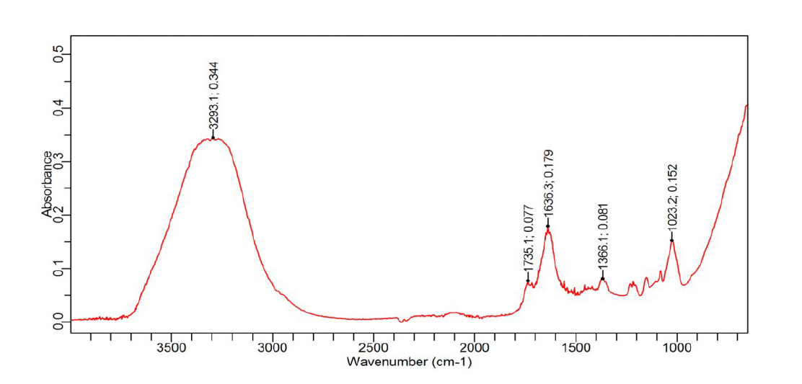**

**Fig. 10**: FTIR spectrum of Cassava root starch adhesive (CRSA)

.

**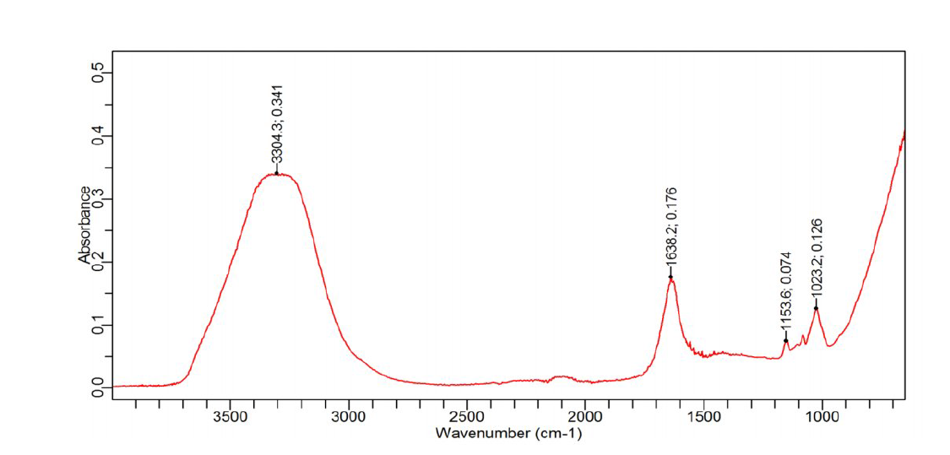**

**Fig. 11:** FTIR spectrum of Cassava peel starch adhesive (CPSA).

for Fig. 13, and up to about 230 °C in film 1, suggesting lower water desorption in Fig. 12. This may be due to the different structure of samples. The second step corresponded to the decomposition of starch. This main stage of degradation occurred initially at 315 °C, according to the peak indicated in the DTG until near 340 °C for Fig. 12, initially at 295 °C up to near 380 °C in Fig. 13, and at 305 °C, according to the peak indicated in the DTG until about 400 °C for Fig. 13, corresponding to about 70% - 80% mass loss. After the decomposition stage, the residual mass should be related to the nature of the starch, impurities and inorganic components. The degradation mechanism consisted of the elimination of polyhydroxyl groups accompanied by depolymerization and decomposition, with the final carbon production.



**Fig. 12:** TGA and DTG curves for the Cassava root starch adhesive

****

**Fig. 13:** TGA and DTG curves for the Cassava peel starch adhesive

**CHAPTER 5**

**CONCLUSION AND RECOMMENDATION**

**5.1 Conclusion**

Having formulated adhesives with starches extracted from both Cassava roots and Cassava peels, using the exact same formula, the findings suggested that adhesives can be made using starch from Cassava peels (CPSA) and such adhesives can be as good as those made from Cassava roots (CRSA). Both CRSA and CPSA exhibited physical characterizations within the limits considered adequate for adhesive applications in wood industry. Also, there were not many differences in the characteristics peaks observed in CPSA when compared with the peaks in CRSA, according to their FTIR analyses. In addition to this, CRSA exhibited a faster curing time than CPSA, while the thermal stability of CPSA is as suitable as that of CRSA for adhesive applications as suggested by the TGA results.

Hence, it can be concluded that starch from Cassava peels presented a great potential for application in adhesive formulation, contributing to the reduction of environmental impacts from its inappropriate disposal, reduction of food shortage as a result of using Cassava roots in non-food applications and to the sustainability of the future generation. However, there may be room for improvement in CPSA in order to match the advantageous properties of CRSA.

**5.2 Recommendation**

As a result of this insightful research, I would like to make the following recommendations;

* Adequate research should be made on the use of starch from Cassava peel in the formulation of adhesives.
* More research should be made in the employability of starch from Cassava peels in other non-food applications in order to reduce its environmental degradation
* In general, wood industries should support green production by massively adopting the use of starch-based adhesives and other bioadhesives in their manufacturing processes.

**REFERENCE**

Abiaziem, C. V and Ojelade, I. A (2019). ‘Cassava peel wax: its extraction and characterisation’, *Journal of Chemical, Biological and Physical Sciences, 9* (4), pp. 316-322. <http://eprints.federalpolyilaro.edu.ng/id/eprint/345>

(Accessed: 12 April 2023)

Akpa, J. G. (2012). ‘Production of cassava starch-based adhesive’, *Research Journal in Engineering and Applied Sciences*, 1(4), pp. 219-214. Available at: <https://www.emergingresource.org>

Ambuja (2021). ‘Introduction to adhesives: composition, types, and uses’. Available at:

<https://www.ambujasolvex.com/blog/introduction-to-adhesives-composition-types-and-uses/>

(Accessed: 23 November 2022).

ASTM int., ASTM D905-08 (2013). ‘*Standard test method for strength properties of adhesivebonds in shear by compression loading’*

<https://doi.org/10.1520/D905>

Astrouski, I., Kudelova, T., Kalivoda, J. and Raudensky, M. (2020). ‘Shear strength of adhesive bonding of plastics intended for high temperature plastic radiators,’ *Processes,* 10(5), pp. 806.

<https://doi.org/10.3390/pr10050806>

Athavale, S. (2011). ‘*Adhesion and adhesives theory’.* Available at:

<https://www.slideshare.net/05ashrikant58/05adhesion-and-adhesives-theory>

(Accessed: 24 November 2023).

Athavale, S. (2018). ‘*What is Adhesive’*. Conference: PVG college og ngineering and technology

<https://www.researchgate.net/publication/328843077/WHAT-IS-ADHESIVE>

(Accessed: 22 November 2023).

Baini,, T., Demong, M., Chang, J. L. H., Kamal, M. M., Abdul S. N. A. S., Rahman, M. R. and Taib, S. N. L. (2021). ‘Characterization of Bio-adhesive derived from Sarawak Native Sago Starch’, *IOP Conf. Series: Materials Science and Engineering*, 1101, 012041. <https://doi.org/10.1088/1757-899X/1101/1/012041>

Basta, A. H., El-Saied, H.,andLotfy , V. F. (2013). ‘Performance of rice straw‐based composite using environmentally friendly polyalcoholic polymers‐based adhesive system’, *Pigment and Resin Technology,* 42(1), pp. 24-33. <https://doi.org/10.1108/03699421311288733>

Benhamou, A. A., Boussett, A., Kassab, Z., Nadifiyine, M., Sehaqui, H., El Achaby, M. and Moubarik, A. (2022). ‘Elaboration of carboxylated cellulose nanocrystals filled starch-based adhesives for the manufacturing of eco-friendly particleboards’, *Construction and Building Materials,* 348*,* Article 128683. <https://doi.org/10.1016/j.conbuildmat.2022.128683>

Bertoft, E. (2017). ‘Understanding starch structure: Recent progres’, *Journal of Agronomy, 7*(3), pp. 56. <https://doi.org/10.3390/agronomy7030056>

Besley, T. (n.d). *‘The Different Adhesive Testing Methods; Deciding which Test Method is Best for You’.* Available at:

<https://forgeway.com/guide-to-adhesive-testing>

(Accessed: 8 May 2023).

Bhambure, S. and Mallick, P., (2012). *Effects of temperature variation on stresses in Adhesive joints between magnesium and steel.* SAE world congress and Exhibition. DetroitMI, USA

Bostik (2016). ‘*Adhesive Education Series: History of Adhesives’,*  Arkema Company. Available at:

<https://industrial.bostik.com/adhesive-education-series-history-of-adhesives/>

(Accessed: 11 October 2022).

Britannica (2023). ‘*Starch: Chemical Compound*’. Available at:

<https://www.britannica.com/science/starch>

(Accessed: 20 November 2023).

Chen, X., Sun, C., Wang, Q., Tana, H. Zhang, Y. (2022). ‘Preparation of glycidyl methacrylate grafted starch adhesive to apply in high-performance and environment-friendly plywood’, *International Journal of Biological Macromolecules,* 194, pp. 954-961.

<https://doi.org/10.1016/j.ijbiomac.2021.11.152>

Chisenga, S. M., Workneh, T. S., Bultosa, G. and Laing, M. (2019). ‘Characterization of physicochemical properties of starches from improved cassava varieties grown in zambia’, *AIMS Agriculture and Food*, 4(4), pp. 939–966. <https://doi.org/10.3934/agrfood.2019.4.939>

## 

Díaz-Díaz, A., Sánchez-Silva, B., Tarrío-Saavedra, J., López-Beceiro, J.,

Gómez-Barreiro, S. and Artiaga, R. (2020). ‘Curing of adhesive systems by rheological and thermal testing’, *Journal of Visualized Experiments: JOVE,* 3,pp. 161. <https://doi.org/10.3791/61468.PMID:32716389>

Dinte, E. and Slvester, B. (2017). ‘Adhesives: applications and recent advances’, In Ozer Halil (ed.) *Applied adhesive bonding in science and technology*. IntechOpen. <https://doi.org/10.5772/intechopen.71854>

Dong, Z., He, Q., Shen, D., Gong, S., Zhang, W., Ono, T. and Jiang, Y (2023). ‘Microfabrication of functional polyimide films and microstructures for flexible mems application’, *Micosystem Nanoenigineering,* 9, pp. 31. <https://doi.org/10.1038/s41378-023-00503-5>

Ebnesajjad, S. and Landrock, A. H. (2015). ‘Classification of adhesives and compounds’, In: da Silva, L., Ochsner, A., Adams, R. (eds) *Handbook of Adhesion Technology*. Springer, Cham, pp. 67-83.

<https://doi.org/10.1016/B978-0-323-35595-7-00004-8>

Egharevba, H. O. (2019). ‘Chemical properties of starch and its application in the food industry’, In: Emeje. M. (ed.) *Chemical Properties of Starch*. IntechOpen. <https://doi.org/10.5772/intechopen.87777>

El, S., Koraichi, S., Latrache, H. and Hamadi, F. (2012). ‘Scanning electron microscopy (SEM) and environmental SEM: suitable tools for study of adhesion stage and biofilm formation’, *Scanning Electron Microscopy.* <https://doi.org/10.5772/34990>

El-Seoud, O. A., Nawaz, H. and Arêas, E. (2013). ‘Chemistry and applications of polysaccharide solutions in strong electrolytes/dipolar aprotic solvents: An overview’*, Molecules,* 18(1), pp. 1270-313.

<https://doi.org/10.3390/molecules18011270>

FAO (2014). ‘*Cassava Production’*. Available at:

<https://www.fao.org/3/y5548e/y5548e07.htm> (Accessed: 31 April 2023).

Foist, L. (2022). ‘*What is Dextrin*?’ Available at:

[https:/study.com/academy/lesson/what-is-dextrin-in-food-definition- chemical-formula.html](https://study.com/academy/lesson/what-is-dextrin-in-food-definition-%20chemical-formula.html) (Accessed: 20 November 2022).

Forza, T. (2022). ‘*How Important is Adhesive Testing*?’ Available at:

<https://forxabuilt.com/blog/important-of-testing/>

(Accessed: 29 April 2023).

Fraunhofer, J. A. (2012). ‘Adhesion and Cohesion’, *International Journal of Dentistry,* 951324. <https://doi.org/10.1155/2012/951324>

Frihart, C. R. and Hunt, C. G. (2010). ‘Adhesives with wood materials: bond formation and performance’, In Gedeon, G. P. E. (ed.) *Wood, Handbook: Wood as an Engineering Material: Chapter 10. Centennial General Technical Report FPL;* Madison, WI: U.S. Dept. of Agriculture, Forest Service, Forest Products Laboratory,GTR-190, pp. 10.1 – 10.24.

Fronza, P., Costa, A. L. R., Franca, A. S. and de Oliveira, L. S. (2022). ‘Extraction and characterization of strach from cassava peels’, *Starch – Stärke,* 75(3-4), 2100245. <https://doi.org/10.1002/star.202100245>

Gadhave, R. V., Mahanwar, P. A. and Gadekar, P. T. (2017). ‘Starch-based adhesives for wood/wood composite bonding: review’, *Open Journal of Polymer Chemistry,* 7(2). <https://doi.org/10.4236/ojpchem.2017.72002>

Glavas, L. (2011). ‘Starch and Protein based Wood Adhesives’, *Degree project in Polymer Technology 2nd level, 30 ECTS,* Nacka, Sweden.

Hamidu, L. A. J., Aroke, U. O., Osha, O. A. and Muhammad, I. M. (2019). ‘Fourier transform infrared spectroscopy and scanning electron microscopy characetrisation of adhesive produced from polystyrene waste’, *Path of Science,* 5(12), pp. 3001-3008. <https://doi.org/1022178/pos.53-4>

Hartline, R. (2023). *‘Starch Hydrolysis’.* Available at:

<https://bio.libretexts.org/Bookshelves/Microbiology/Microbiology_LaboratoryManual_(Hartline)/01%3A_Labs/1.17%3A_Starch_Hydrolysis> (Accessed: 20 April 2023).

# [Henley](https://patents.google.com/?inventor=Matthew+J.+Henley), M. J. (2014). ‘Stable high viscosity starch based adhesive and method of preparation (U.S. Patent No. 5753468A)’, *U.S. Patent and Trademark Office*. Available at:

# [https://patents.google.com/patent/US5753468A/en#patentCitations](https://patents.google.com/patent/US5753468A/en" \l "patentCitations)

Hirsh, C. (2022). *‘The Use of FTIR Analysis in Adhesive Manufacturing*’. Available at:

<https://lamartcorp.com/blog/ftir-analysis-in-adhesives-manufacturing/>

(Accessed: 4 May 2023).

Horstmann, S. W., Lynch, K. M. and Arendt, E. K. (2017). ‘Starch characteristics linked to gluten-free product’, *Foods,* 6(4), 29.

<https://doi.org/10.3390/foods6040029>

Jiang, Y., Chen, Q., Tan, H., Gu, J and Zhang, Y. (2019). ‘A low-cost, formaldehyde-free, and high performance starch-based wood adhesive’, *BioResources,* 14(1), pp. 1405-1418.

<https://doi.org/10.15376/biores.14.1.1405-1418>

Kelleci, O., Koksal, S. E., Aydemir, D. & Sancar, S. (2022). ‘Eco-friendly Particleboards with Low Formaldehyde Emission and Enhanced Mechanical Properties Produced with Foamed Urea-formaldehyde Resins’, *Journal of Cleaner Production*, 379, *134785*

<https://doi.org/10.1016/j.jclepro.2022.134785>

Kopeliovich, D. (2012). ‘*Classifications of Adhesives’*. Available at:

<https://www.substech.com/dokuwiki/doku.php?id=classification_of_adhesives>

(Accessed: 11 May 2023).

Krolikowska, K., Pietrzyk, S., Pustkowiak, H. and Wolak, K. (2022). ‘The effect of cassava and wheat starches complexation with selected fatty acids on their functional properties’, *Journal of Food Science and Technology,* 59,pp. 1440 -1449. <https://doi.org/10.1007/s13197-021-05153-x>

# [Kumar](https://www.researchgate.net/profile/Vicky-Kumar-3), V., [Norzila Othman](https://www.researchgate.net/profile/Norzila-Othman-2), N. and [Asharuddin](https://www.researchgate.net/profile/Syazwani-Mohd-Asharuddin), S. M. (2020). ‘*Partial replacement of alum by using natural coagulant aid to remove turbidity from institutional wastewater’.* Available at:<https://www.researchgate.net/publication/341832518_Partial_Replacement_ofAlum_by_Using_Natural_Coagulant_Aid_to_Remove_Turbidity_from_Institutional_Wastewater>

# (Accessed: 17 April 2023).

Lamaming, J., Heng N. B., Owodunni, A. A., Lamaming, S.Z., Khadir, N. K. A., Hashim, R., Sulaiman, O., Kassim, M. H .M., Hussin, M. H. and Bustami, Y. (2020). ‘Characterization of rubberwood particleboard made using carboxymethyl starch mixed with polyvinyl alcohol as adhesive’, *Composites,* 183, 107731. <https://10.1016/j.compositesb.2019.107731>

Lewicka, K., Siemion, P. and Kurcok, p. (2015). ‘Chemical modifications of starch: microwave effect’, *International Journal of Polymer Science*, 867697. <https://doi.org/10.1155/2015/867697>

Li, D., Zhuang B., Wang X., Wu Z., Wei W., Aladejana J.Y., Hou X., Yves K.G., Xie Y., Liu J. (2020). ‘Chitosan used as a specific coupling gent to modify starch in preparation of adhesive film’, *Journal of Clean Product,* 277, 123210. <https://doi.org/10.1016/j.jclepro.2020.123210>

Lowry, S. and Weensner, F. (2011). ‘Using Real-Time FT-IR to Characterise UV Curable Optical Adhesives’, *Spectoscopy: Solutions fro Materials Analysis,* 26(8). Available at:

<https://www.spectroscopyonline.com/view/using-real-timeft-ir-characterize-uv-curable-optical-adhesive>

Mandala, I. G.(2012). ‘Viscoelastic properties of starch and non-starch thickeners in simple mixtures or model food’, In De Vincente, J. (eds) Viscoelasticity–from Theory to Biological Applications.

<https://www.intechopen.com/books/2854>

Manoj (2022). ‘*Adhesion: Definition, Theory and Types’.* Available at:

<https://www.tribonet.org/wiki/adhesion-definition-theory-and-types/>

(Accessed: 5 November 2022).

Masina, N., Choonara, Y. E., Kumar, P., Toit, L. C., Govender, M., Indermun, S. and Viness, P. (2017). ‘A review of the chemical modification techniques of starch’, *Carbohydrate Polymers,* 157,pp. 1226–1236.

<https://doi.org/10.1016/j.carbpol.2016.09.094>

Mehmood, K. (2019). ‘*Starch Based biopolymer’.* Available at:

<https://www.slideshare.net/muhammadzubair547/starch-based-biopolymer>

(Accessed: 1 December 2022).

Monteiro, S.C.C. (2020). ‘Development of low-density particleboards bonded with starch-based adhesive’, *Laboratory for Proccess Engineering, Environment, Biotechnology and Energy,*

Monteiro, S., Martins, J., Magalhães, D. F. and Carvalho, L. (2016). Low densitywood-based particleboards bonded with foamable sour cassava starch: preliminary studies’, *Polymers,* 8, PP. 354; <https://doi.org/10.3390/polym8100354>

Nasiri, A., Wearing, J. and Dubé, M. A. (2020). ‘Using lignin to modify starch-based adhesive performance’, *Chemical Engineering,* 4(1), pp. 3.

<https://doi.org/10.3390/chemengineering4010003>

Nawaz, H., Waheed, R., Nawaz, M. and Shahwar, D. (2020). ‘Physical and Chemical Modifications in Starch Structure and Reactivity. In: Emeje, M. (ed.) *Chemical Properties of Starch*. <https://doi.org/10.5772/intechopen.88870>

Oladunmoye, O. O., Aworh, O. C., Maziya-Dixon, B., Erukainure, O and Elemo, G. N. (2014). ‘Chemical and functional properties of cassava starch, durum wheat semolina flour, and their blends’, *Food Science and Nutrition,* 2(2), pp. 132-138. <https://doi.org/10.1002/fsn3.83>

# [Olaleru](https://www.researchgate.net/profile/Ibikunle-Olaleru), I., [Oke](https://www.researchgate.net/scientific-contributions/T-D-Oke-2175525218), T. D. and [Adepegba](https://www.researchgate.net/profile/Victoria-Adepegba-2), V. (2015). Performance of Broiler Chicken Fed Diets Containing Cassava Peel and Leaf Meals as Replacements for Maize and Soya Bean Meal. Available at:

# <https://www.researchgate.net/publication/341741381_Performance_ofBroiler_Chicken_Fed_Diets_Containing_Cassava_Peel_and_Leaf_Meals_as_Replacements_for_Maize_and_Soya_Bean_Meal>

# (Accessed: 17 January 2023)

# Olayinka , [F. S.](https://pubmed.ncbi.nlm.nih.gov/?term=Olayinka%20F.%5BAuthor%5D), Olayinka, O. O., [Olu-Owolabi](https://pubmed.ncbi.nlm.nih.gov/?term=Olu-Owolabi%20BI%5BAuthor%5D), B. I. and Adebowale, K. O. (2015). ‘Effect of chemical modifications on thermal, rheological and morphological properties of yellow sorghum starch’, *Journal of Food Science and Technology,* 52(12), pp. 8364–8370.

# https://doi.org/[10.1007/s13197-015-1891-3](https://doi.org/10.1007%2Fs13197-015-1891-3" \t "_blank)

Opara, I. J, Ossi, C. D. and OkoUdu, C. O. (2017). ‘Formulation of cassava starch-based adhesive’, *International Journal of Advance Research,* 5(7), pp. 26-33. <http://dx.doi.org/10.21474/IJAR01/4689>

# Otoikhian S. K., Ayo M. D., Salaudeen Z. I. and Diamond B. (2018). ‘Production of wood adhesive from locally sourced material’, Chemical Engineering,

# <https://www.edouniveristy.edu.ng/oer/journal/production_of_wood_adhesive_from_locally_sourced_material>

Packham, D. E. (2017). ‘*Theories of Fundamental Adhesion’*, In da Silva, L., Ochsner, A., Adams, R. (ed.) Handbook of Adhesion Technology. Springer, Cham. <https://doi.org/10.1007/978-3-319-42087-5_2-2>

Pike, R. A. (2022). ‘*Chemistrry: Adhesive*’. Britannica. Available at:

<https://www.britannica.com/technology/adhesive>

(Accessed: 1 January 2023).

Poulis, J. A., Mosleh, Y., Cansell, E., Cimino, D., Ploeger, R., E., Rie, R., McGlinchey, C. W. and Seymour, K. (2022). ‘Mechanical and physical characterization of natural and synthetic consolidants’, *International Journal of Adhesion and Adhesives,* 117, 103015.

<https://doi.org/10.1016/j.ijadhadh.2021.103015>

Roquette (2013). ‘*Bonding Solutions for the Corrugating Industry*’. Available at: [https://www.scribd.com/document/402131987/Roquette-Industry-Paper-Board-Brochure-Corrugating#](https://www.scribd.com/document/402131987/Roquette-Industry-Paper-Board-Brochure-Corrugating) (Accessed: 12 February 2023).

Sancaktar, E. (2011). ‘Classification adhesive and sealant materials’, In da Silva, L. F. M., Ochsner, A., and Adams, R.D. (ed.), *Handbook of Adhesion Technology.* Springer, Berlin, Heidelberg. <https://doi.org/10.1007/978-3-642-01169-6_12>

Souto, L. R. F., Caliari, M., Júnior, M. S., Fiorda, F. A. and Garcia, M. C. (2017). ‘Utilization of residue from cassava starch processing for production of fermentable sugar by enzymatic hydrolysis’, *Food Science and Technology,* 37(1), pp. 19-24. <https://dx.doi.org/10.1590/1678-457x.002>

Srivastava, T., Katari, N. K., Ravuri, B. R., Kushwaha, J., Mohan, K. S. and Jonnalagadda, S. B. (2020). ‘Studies on thermal stability and life estimation of epoxy adhesive by thermogravimetric analysis for high temperature application’, *Bulletin of Material Science,* 43*,* pp. 163.

<https://doi.org/10/1007/5/2034-020-02152-0>

Su, M., Wu, J., Pan, P. and Wang, H. (2022). ‘Preparation, and characterization of a water-resistant polyamide-oxidized starch-methyl methacrylate eco-friendly wood adhesive’, *Internationl Journal of Biologica. Macromolecules*, 194, pp. 763–769.

<https://doi.org/10.1016/j.ijbiomac.2021.11.123>

Sun, J., Li, L., Cheng, H. and Huang, W. (2016). ‘Preparation, characterization and properties of an Organic siloxane-modified cassava starch-based wood adhesive’, *Journal of Adhesion,* 94(4), pp. 278-293.

<https://doi.org/10.1080/00218464.2016.12.68958>

Sun, Y., Gu, J., Tan, H., Zhang, Y. and Huo, P. (2018). ‘Physicochemical properties of starch adhesives enhanced by esterification modification with dodecenyl succinic anhydride’, *International Journal of Biological Macromolecules,* 112,pp. 1257-1263.

<https://doi.org/10.1016/j.ijbiomac.2018.01.222>

Susanti, S., Al Karoma, D., Mulyani, D. and Masruri, M. (2017). ‘Physical properties and characterization of cassava peel waste modified br esterification’, *Journal of Pure and Applied Chemistry Research,* 6, pp. 225. <https://doi.org/10.21776/ub.jpacr.2017.006.03.346>

Thathsaranee, V. W. T., Moghaddam, L., Welsh, Z. G. Wang, T., Xiao, H. and Karim, A. (2023). ‘Extraction and characterisation of starch from cassava (*Manihot Esculenta*) agro-industrial wastes’, *Journal of Food Science and Technology,* 182, 114787. <https://doi.org/10.1016/j.wt.2023.114878>

Ulker, O. and Hiziroglu, S. (2020). ‘Some properties of composite panels manufactured from eastern redcedar (Juniperus virginiana L.) using modified starch as a green binder’, *Journal of Natural Fibers*, 14(4), pp. 541-550. <https://doi.org/10.1080/15440478.2016.1240642>

[Vanier](https://pubmed.ncbi.nlm.nih.gov/?term=Vanier+NL&cauthor_id=27979128), N. L., El Halal, S. L. M., [Dias](https://pubmed.ncbi.nlm.nih.gov/?term=Dias+ARG&cauthor_id=27979128), A. R. G. and  [Zavareze](https://pubmed.ncbi.nlm.nih.gov/?term=da+Rosa+Zavareze+E&cauthor_id=27979128), E. R. (2017). ‘Molecular structure, functionality and applications of oxidized starches: A review. Food Chemistry, 221, pp. 1546-1559.

<https://doi.org/10.1016/j.foodchem.2016.10.138>

Vineeth, S. K., Gadhave, R. V. and Gadekar, P. T. (2021). ‘Investigation of cross-linking ability of sodium metabisulphite with polyvinyl alcohol–corn starch blend and its applicability as wood adhesive’, *Indian Chemical Engineer,* 64(2), pp. 197-207.

<https://doi.org/10.1080/00194506.2021.1887769>

Wang, Z., Li, Z., Gu, Z., Hong, Y. and Cheng, L. (2012). ‘Preparation, characterization and properties of starch-based wood adhesive’, *Carbohydrate Polymers,* 88(2), pp. 699-706.

<https://doi.org/10.1016/j.carbpol.2012.01.023>

Wang, Z., Zhu, H., Nan, J. H., Ge, Z., Guo, J., Feng, X. and Xu, Q. (2019). ‘Improvement of the bonding properties of cassava starch-based wood adhesives by using different types of acrylic ester’, *International Journal of Biological Macromolecules,* 126*,* pp. 603-611*.*

<https://doi.org/10.1016/j.ijbiomac.2018.12.113>

Wasistha, A. W., Dika, M. R. S., Aulla, A. S., Samudra, N. m. and Putri, D. N. (2021). Physical and Mechanical Characteristics of Edible Film Based on Cassava Peel Starch. *Journal of Food Technology, 5*(2).

<https://doi.org/10.32585/ags.v5is.1877>

Watcharakitti, J., Ein, E. E., Nimnuan, J. and Smith, S. M. (2022). ‘Modified starch-based adhesives: A review’, *Polymers,* 13,2023. <https://doi.org/10.3390/polym14102023>

Xiaoyu, F. (2021). ‘*Cassava as an Important Staple Food and its Application in the Food Industry- A Review’.* Available at:

<https://www.ecommons.cornell.edu/handle/1813/111054>

(Accessed: 3 February 2023).

Xing, J., Li, T., Yu, Y., Chen, C. and Chang, J. (2018). ‘Development and characterization of a new bio-adhesive for wood using cassava starch and bio-oil’, *International Journal of Adhesion and Adhesives,* 87, pp. 91-97.

<https://doi.org/10.1016/j.ijadhadh.2018.09.005>

Xu Q., Wen J., Wang Z. (2016). ‘Preparation and Properties of Cassava Starch-based Wood Adhesives’, *BioResources,* 11, pp. 6756–6767. <https://doi.org/10.15376/biores.11.3.6756-6767>

Yu, H., Cao, Y., Fang, Q., and Liu, Z. (2015). ‘Effects of treatment temperature on properties of starch-based adhesives’, *BioResources,* 10(2), pp. 3520-3530. Available at:

<https://bioresources.cnr.ncsu.edu/resources/effects-of-treatment-temperature-on-properties-of-starch-based-adhesives/>

Zhang, Y., Ding, L., Gu J. Tan, H. and Zhu, L. (2015). ‘Preparation and properties of a starch-based wood adhesive with high bonding strength and water resistance’, *Carbohydrate Polymers,* 115, pp. 41947-41955.

<https://doi.org/10.1016/j.carbpol.2014.08.063>

Zhao X.F., Peng L.Q., Wang H.L., Wang Y.B., Zhang H. (2018). ‘Environment-friendly urea-oxidized starch adhesive with zero formaldehyde-emission’, *Carbohydrates Polymers,* 181, pp. 1112–1118.

<https://doi.org/10.1016/j.carbpol.2017.11.035>

Zia-ud-Din, Chen,L., Ullah, I., Wang, P. K., Javaid, A. B., Hu, C., Zhang, M., Ahamd, I., Xiong, H, and Wang, Z. (2018). ‘Synthesis and characterization of starch-g-poly(vinyl acetate-co-butylacrylate) bio-based adhesive for wood application’, *International Journal of Biological Macromolecules,* 114, pp. 1186–1193. <https://doi.org/10.1016/j.ijbiomac.2018.03.178>